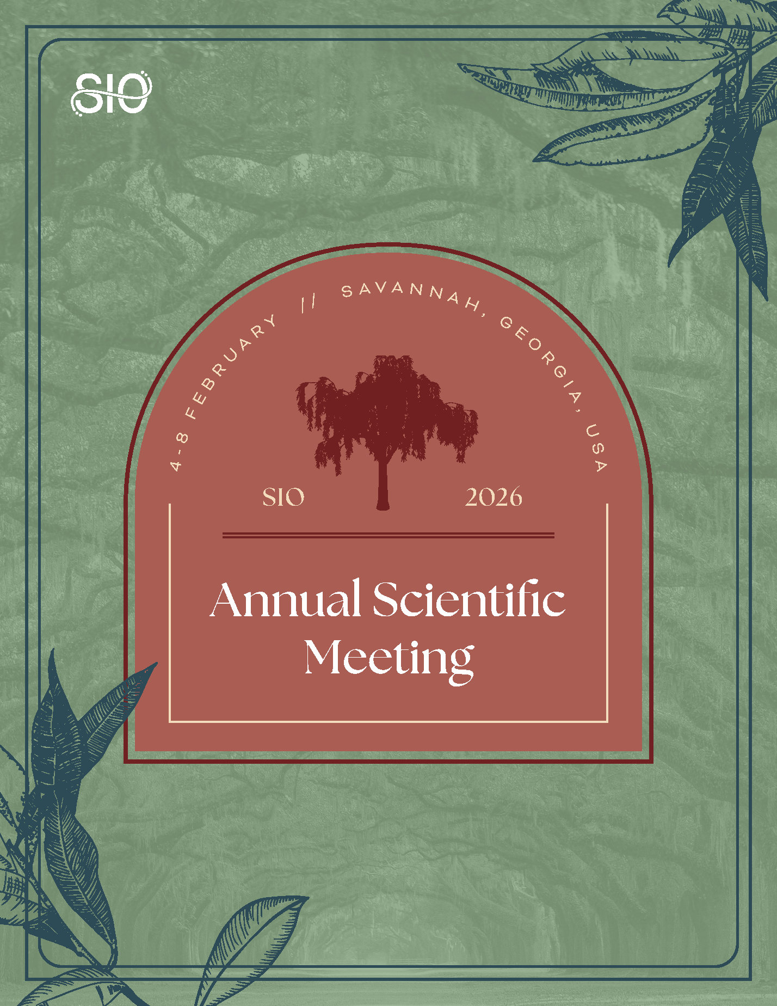
MARKETING TOOLKIT
Thank you for taking the time to exhibit at the Society of Interventional Oncology (SIO) 2026 Annual Scientific Meeting! This comprehensive marketing kit has been designed to help you spread the word and publicize your participation. Inside, you’ll find a wide range of promotional resources, templates, and graphics that are sure to generate some buzz. Happy sharing!
Let your online network know why they should join you 4 – 8 February in Savannah, Georgia, by utilizing the provided:
- Talking Points
- Pass-Along Email Template
- Social Media Messaging
- Shareable Graphics and Photos
Questions?
Visit the SIO website or reach out to us at info@sio-central.org.

TALKING POINTS
What is the SIO Annual Scientific Meeting?
The SIO Annual Scientific Meeting is the premier event for interventional oncology (IO) professionals. Since its inception, it has provided comprehensive learning sessions, opportunities for face-to-face networking, and skill-building activities for practitioners across the globe. The 2026 event — taking place 4 - 8 February in Savannah, Georgia — is expected to deliver just that and more.
Why Attend?
Learn About the Latest in IO
Whether you’re a student, mid-career professional, or IO expert, the SIO 2026 Annual Scientific Meeting provides education for individuals at every career level. This year’s program boasts an impressive lineup of hands-on workshops, learning sessions, and expert-led lectures. View the full online schedule here.
Advance Your Expertise
New at the SIO 2026 Annual Scientific Meeting, the inaugural Palliative Pain in Cancer Patients Master Class delivers a comprehensive, case-driven experience designed to elevate the interventional oncologist’s approach to cancer-related pain. SIO is also proud to host The RISE Forum, a comprehensive, expert-led program designed to equip interventional oncologists, scientists, and clinical investigators with the tools and knowledge to advance impactful research across the translational spectrum. From foundational laboratory platforms to clinical trial design and next-generation innovations, this immersive course spans the critical elements necessary for driving discovery and accelerating clinical progress in interventional oncology.

Experience IO Essentials Programming
The IO Essentials Program — taking place Wednesday, 4 February – Saturday, 7 February 2026 — was designed by leading experts in IO to provide early-career attendees with an opportunity to participate in hands-on learning, dive into cutting-edge research, and collect tips on how to build a successful clinical practice.
Create New Connections
The SIO Annual Scientific Meeting cultivates a collaborative environment, attracting leading industry partners, medical students, residents, researchers, scientists, physicians, health specialists, and other medical professionals from across the globe. During the five-day event, you are encouraged to exchange ideas, share best practices, and identify growth opportunities through our face-to-face networking functions.
Score Significant Savings
Join the SIO community to secure the best available rate on this can't-miss event. By becoming a member, you will receive discounted registration to all SIO events — like the Annual Scientific Meeting — inclusion in the member directory, exclusive educational opportunities, and countless other year-round benefits. Bundle your registration with an SIO membership today!
Stay Close to Action
SIO has reserved a block of discounted rooms for the SIO 2026 Annual Scientific Meeting at The Westin Savannah Harbor Golf Resort & Spa and at The Marriott Savannah Riverfront, near the Savannah Convention Center. The discount rate is $275 per night, plus taxes and fees. The cut-off date to book your room is Monday, 5 January 2026, or until rooms are sold out — whichever occurs first.

PASS ALONG EMAIL
Spread the word about the SIO 2026 Annual Scientific Meeting by sending an email invitation to members of your professional network. Customize the template below.

Subject: Join Me at the SIO 2026 Annual Scientific Meeting
Hi [insert name of recipient],
I am excited to share that [insert company name] is exhibiting at the SIO Annual Scientific Meeting, taking place 4 – 8 February in Savannah, Georgia. This can’t-miss event is led by the best and brightest in the field of interventional oncology (IO), providing unparalleled opportunities to acquire knowledge, create connections, and elevate your professional skill set.
With workshops covering innovative topics, you will leave feeling empowered to bring new techniques and practices back to your workplace. This year, [insert company name] is excited to showcase [insert expo product or service].
If you would like to learn more or register, please visit the SIO website.
I hope to see you there!

[insert your name and signature]

SOCIAL MEDIA MESSAGING
Leverage social media to promote your participation at the SIO 2026 Annual Scientific Meeting. Feel free to copy/paste the posts below, or make a message of your own, to keep your online network in the know.
Don’t forget to follow our channels to stay up to date on all things leading up to #SIOSavannah!
- Facebook: @SIOcentral
- LinkedIn: Society of Interventional Oncology
- X: @SIO_Central
X Posts
- We are thrilled to announce that we [or insert company name] will be exhibiting at #SIOSavannah 4 – 8 February 2026. Come learn more about [insert expo product or service] at booth [insert booth number]. https://www.sio-central.org/Events/Annual-Scientific-Meeting
- Connect with my company, [insert company name], at #SIOSavannah to learn more about [insert expo product or service]! Learn more and register for this can't-miss event now: https://www.sio-central.org/Events/Annual-Scientific-Meeting
- #SIOSavannah is taking place 4 - 8 February 2026! Stop by and say “hi” as [insert company name] holds down the fort at booth [insert booth number]. https://www.sio-central.org/Events/Annual-Scientific-Meeting
- We are so excited for #SIOSavannah and would love to see you there! Add “visit booth [insert booth number]” to your bucket list for 2026. Register today: https://www.sio-central.org/Events/Annual-Scientific-Meeting/Registration
Facebook/LinkedIn Posts
- We are thrilled to announce [insert company name] will be exhibiting at the SIO 2026 Annual Scientific Meeting! Join us 4 – 8 February to learn all about our latest [insert expo product or service]! Visit the SIO website to secure your spot now: https://www.sio-central.org/Events/Annual-Scientific-Meeting/Registration
- Are you attending #SIOSavannah? Stop by booth [insert booth number] to learn all about [insert company name]’s [insert expo product or service]! Join us in the Savannah: https://www.sio-central.org/Events/Annual-Scientific-Meeting/Registration
- [Insert company name] is a proud supporter of advancements in the field of interventional oncology (#IO). That’s why we are excited to join SIO at the 2026 Annual Scientific Meeting as an exhibitor. Visit the SIO website to learn more about this premier event and register today: https://www.sio-central.org/Events/Annual-Scientific-Meeting/2026-Program
- Visit [insert company name]’s booth, [insert booth number], at the SIO 2026 Annual Scientific Meeting to learn more about [insert expo product or service]! Register today to stay ahead of the latest trends: https://www.sio-central.org/Events/Annual-Scientific-Meeting/Registration

SHAREABLE GRAPHICS
Catch the eyes of your connections by including a branded visual in your next #SIOSavannah email or social media post. Click here to download the full suite of graphics.
TIPS AND TRICKS FOR SOCIAL MEDIA SUCCESS:
- In addition to posting on your personal social media accounts, consider promoting the event in a related group you belong to — just be sure to abide by group policy.
- Customization can go a long way! Pair your post with a personal message, graphic, or picture from a past event to help drive engagement.
- Don’t forget to tag SIO and use the #SIOSavannah to boost visibility.

Flaunt Your Photos
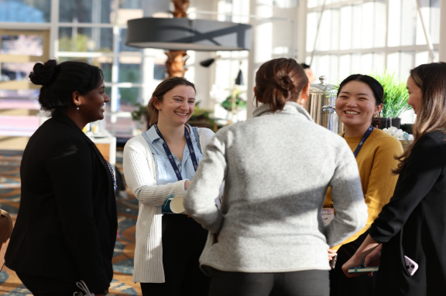
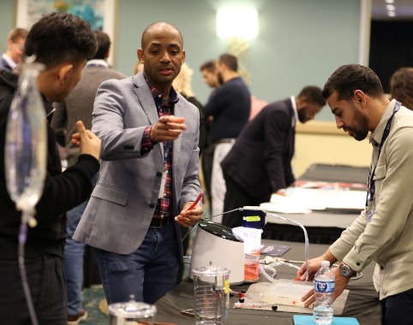
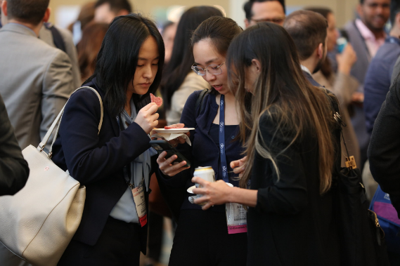
Are you a returning participant? Show off your on-site photos from past events to convey to your network just how empowering the SIO Annual Scientific Meeting can be. While you are at it, flip through the photos featured in our digital gallery to see if you can spot any familiar faces from the annual meetings of yesteryear.

